[ Insert official UPAEP logo ]
UPAEP · Decanato de Ingenierías
EVIDENCE — SPR-T1
End-to-end integration test
SmartGreenAI: Cilantro Crop

1. Task information
Task ID | SPR-T1
User Story | Sprint-level task
Sprint | Sprint 3 (2026-10-12 – 2026-10-30)
Week | Week 3
Responsible | Whole team (facilitated by Jorge)
Peer reviewer | Whole team
Planned / actual hours | Sprint-level task (not estimated in hours)
Completed on | October 29, 2026
Status | Done

2. Task description
Run the flow with the whole team: low soil moisture from the simulator, alert with severity, alert history, automatic irrigation, event log, manual irrigation and anomaly detection. Record a short video or screenshots of every step.

3. Completion conditions
✓ Condition 1: Complete flow executed from low-moisture reading to recorded irrigation event.
How it was verified: The complete flow was executed from the low-moisture reading to the recorded irrigation events: alert with severity → history → automatic irrigation → event log → manual irrigation → anomaly detection.
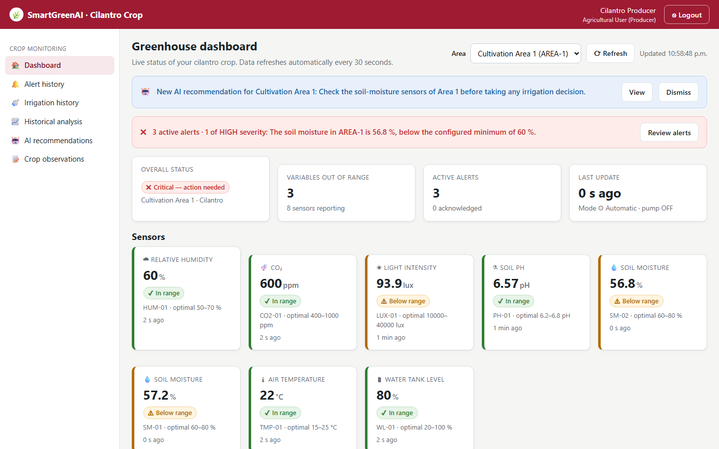
Figure SPR-T1-1. Step 1–2 — low soil moisture from the node: alert with severity on the dashboard. (Sprint3_SPR-T1_End-To-End_Integration_Test_1.png)
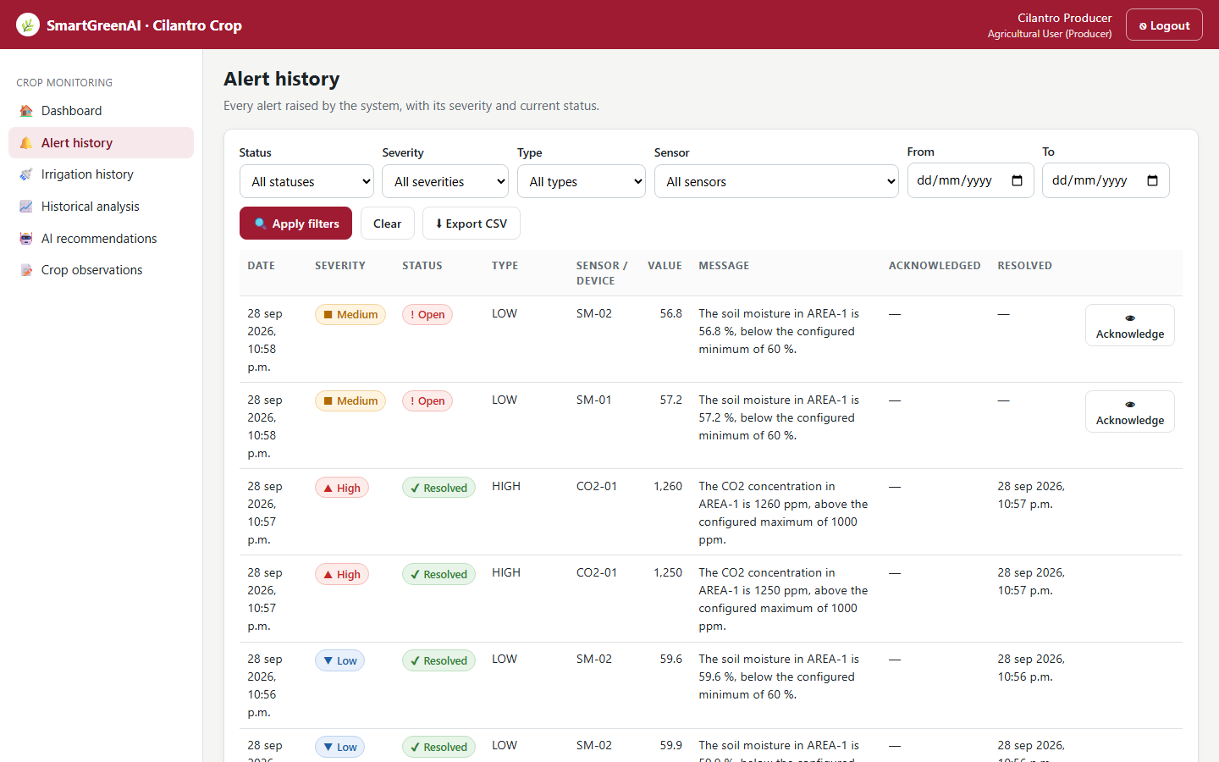
Figure SPR-T1-2. Step 3 — the alert in the alert history. (Sprint3_SPR-T1_End-To-End_Integration_Test_2.png)
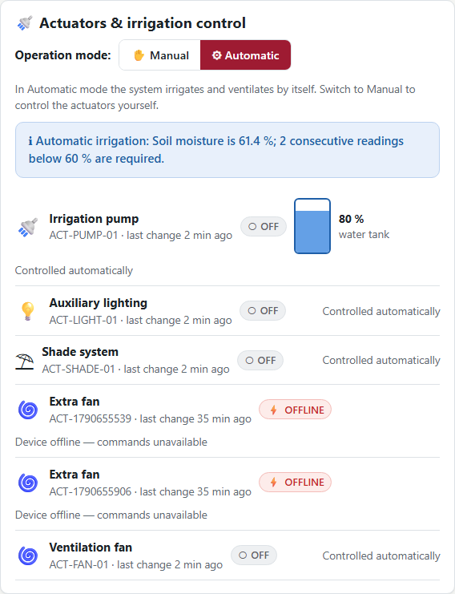
Figure SPR-T1-3. Step 4 — automatic irrigation started by the engine. (Sprint3_SPR-T1_End-To-End_Integration_Test_3.png)
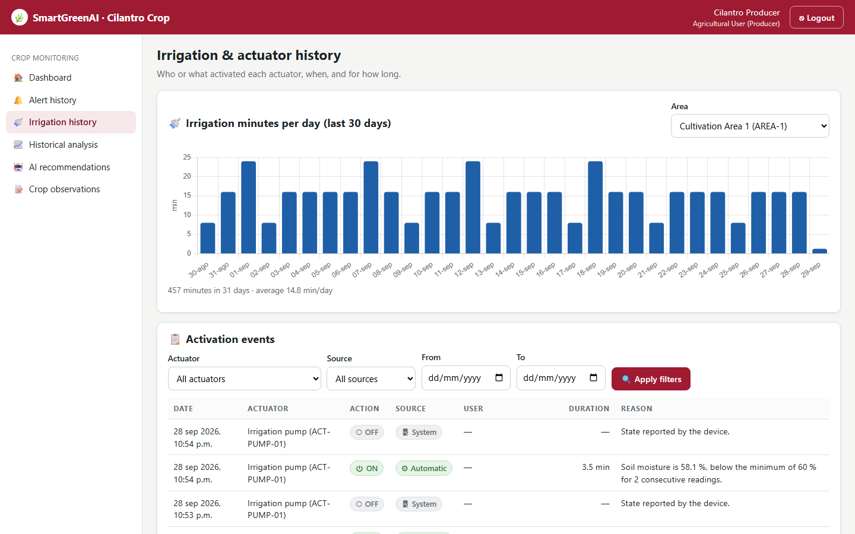
Figure SPR-T1-4. Step 5 — the event log with the automatic activation. (Sprint3_SPR-T1_End-To-End_Integration_Test_4.png)
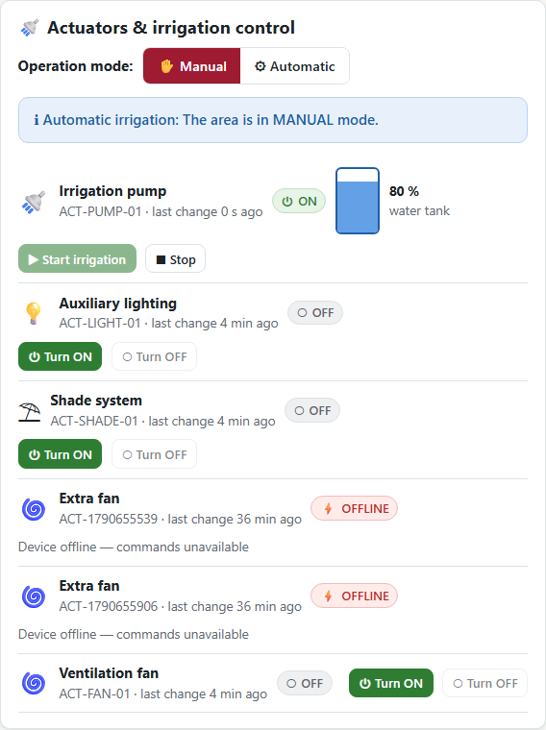
Figure SPR-T1-5. Step 6 — manual irrigation from the dashboard. (Sprint3_SPR-T1_End-To-End_Integration_Test_5.png)
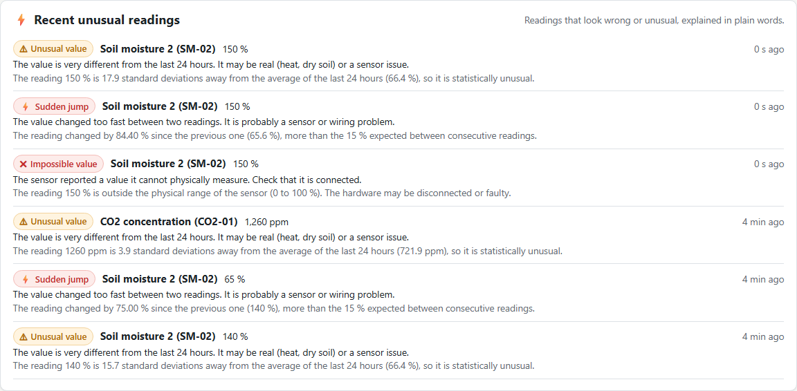
Figure SPR-T1-6. Step 7 — anomaly detection: an impossible reading is flagged and explained. (Sprint3_SPR-T1_End-To-End_Integration_Test_6.png)
✓ Condition 2: Every team member participated with their part working.
How it was verified: Every story of the sprint took part through its owner's component: US-11 (Jorge), US-12 and US-13 (Carlos), US-15 (Vicente), US-16 (Oscar), US-17 (Carlos), US-19 (Alexis).
✓ Condition 3: Video/screenshots saved and defects registered on the board.
How it was verified: Video (Sprint3_SPR-T1_End-To-End_Integration_Test_7.webm) and screenshots are saved; defects found are listed with their resolution (docs/TEST_PLAN.md).
Defects found
ID | Story | Defect | Resolution | Status
D-06 | US-11 | A z-score outlier suppressed real threshold alerts (a heat spike raised no alert) | Only fault anomalies (out of range, sudden jump) suppress alerts | Fixed and retested
D-07 | US-16 / US-20 | Z-score flags hid a real drying trend from the engine and the AI (no irrigation) | Z-score anomalies no longer invalidate readings | Fixed and retested
D-08 | US-13 | A second acknowledgement overwrote who acknowledged the alert | Acknowledgement is idempotent | Fixed and retested
D-09 | FR-18 | The lighting window used UTC hours instead of the greenhouse time | platform.timezone = America/Mexico_City | Fixed and retested
D-10 | US-16 | Manual and automatic commands could conflict (Daily Meeting 3) | Never create a command while another one is pending | Fixed
D-11 | US-06 | Accelerated simulator runs sent timestamps in the future | Readings carry the real clock time; physics accelerated only | Fixed and retested

✓ Condition 4: Evidence: Integration video / screenshots and list of defects found.
How it was verified: Integration video, step screenshots and list of defects.

4. Attached files
- Sprint3_SPR-T1_End-To-End_Integration_Test_1.png
- Sprint3_SPR-T1_End-To-End_Integration_Test_2.png
- Sprint3_SPR-T1_End-To-End_Integration_Test_3.png
- Sprint3_SPR-T1_End-To-End_Integration_Test_4.png
- Sprint3_SPR-T1_End-To-End_Integration_Test_5.png
- Sprint3_SPR-T1_End-To-End_Integration_Test_6.png
- Sprint3_SPR-T1_End-To-End_Integration_Test_7.webm

5. Traceability
Related requirements | All requirements of the sprint
Implementation | alert → command → event chain
Verification | npm run acceptance steps 5–6, 10–14

6. Sign-off
Role | Name | Date | Signature
Responsible | Whole team (facilitated by Jorge) | October 29, 2026
Peer reviewer | Whole team | October 29, 2026
Product Owner acceptance | Alexis Enrique Valle Parra | October 29, 2026
Approval record: Sprint 3 Review & Delivery (October 30, 2026): "Product Owner accepted the seven user stories: all acceptance criteria met."

